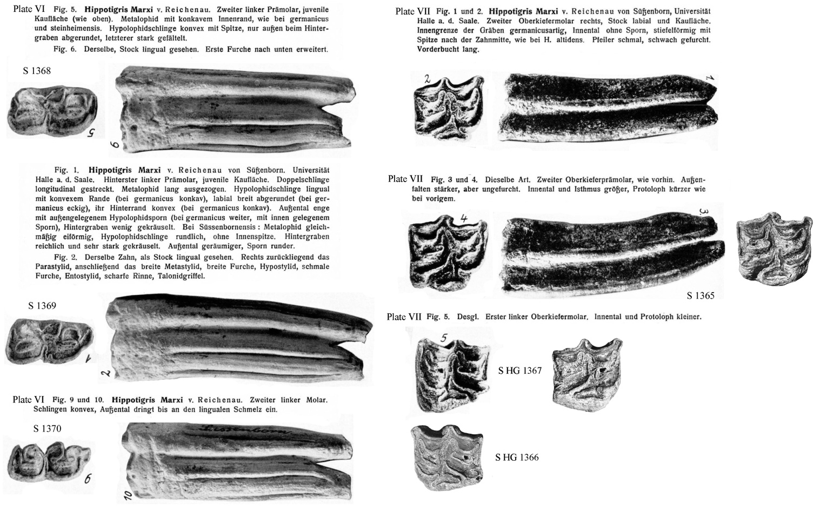

Figure S17. Pictures and captions published by Reichenau [106] for *Hippotigris marxi* and photographs and accession numbers of the teeth when they could be traced in the Institut von Quartär Paläontologie collections in Weimar.